Q-1 Are the HTML tags and elements the same thing?

**ANS:** No, because the HTML tags are building blocks of HTML page.HTML elements are components that are used in HTML page.

**Example:**

**HTML tag: <tagname></tagname>**

**HTML elements: <tagname>content</tagname>**

Q-2 What are tags and attributes in HTML?

**ANS:** HTML tags are used to hold the HTML element.

HTML attributes are used to describe the characteristic of an HTM L elements in detail.

**Example:**

HTML tag: <h1> </h1>

HTML attributes: <h1 align=”center”> content </h1>

Q-3 What are void elements in HTML?

**ANS:** Avoid element is an element whose content model never allows it to have contents under any circumstances. Void elements in HTML: area, base, br, hr, img, input, embed, meta, source, wbr.

Q-4: What are HTML Entities?

**ANS:** HTML entities are the reserved characters that have special meaning when used in an HTML document. Each of these codes stars with an ampersand and end with a semicolon. Now that we have understood the definition of HTML entities, let’s go ahead and explore what symbol and character entities are.

For example:

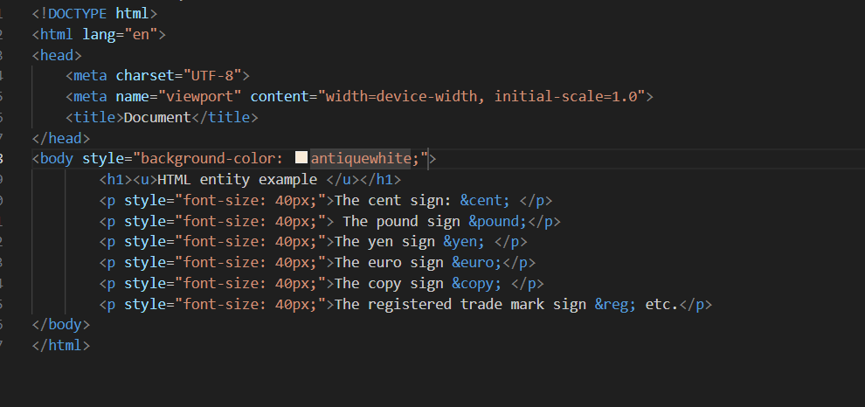

Output:

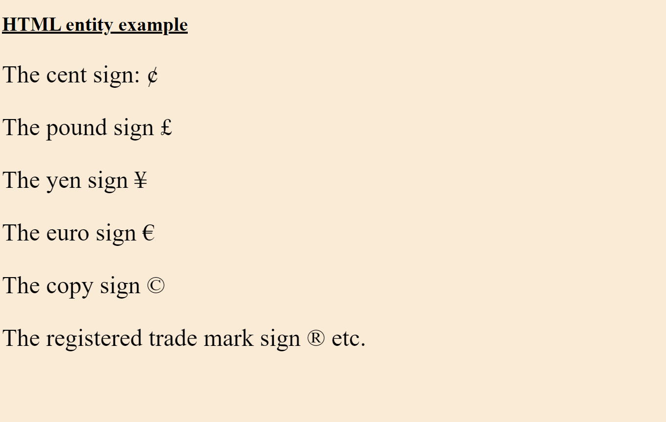

Q-5 What are different types of lists in HTML?

**Ans:** HTML lists come in three categories:

1.Unorder list:

An unordered list starts with the <ul> tag. Each list item starts with the <li> tag. The list items will be marked with bullets by default.

|  |  |
| --- | --- |
| **Value** | **Description** |
| Disc | Sets the list items marker to a bullet (by default). |
| Circle | Sets the list item marker to a circle. |
| Squar | Sets the list items market to a squar. |
| none | The list item will not be marked. |

**Example:**

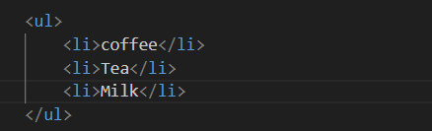

2.Ordered list:

An ordered list starts with the <ol> tag. Each list items starts with the <li> tag. The list items will be marked with numbers by default:

**Example:**

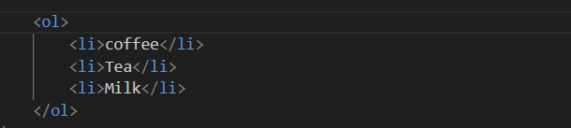

|  |  |
| --- | --- |
| **Type** | **Description** |
| type=”1” | The list items will be numbered with numbers (by default). |
| type=”A” | The list items will be numbered with uppercase. |
| type=”a” | The list items will be numbered with lowercase. |
| type=”I” | The list items will be numbered with uppercase roman numbers. |
| type=”i” | The list items will be numbered with lowercase roman numbers. |

3.Definition list.

Definition list displays elements in definition form like in directory. The <dl> <dt> and <dd> tags are used to define definition list.

The 3 HTML description list tags are given below:

1. <dl> tag defines the description list.
2. <dt> tag defines data term.
3. <dd> tag defines data definition.

**Example:**

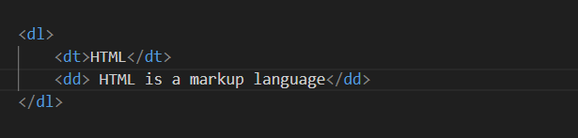

Q-6 What is the ‘class’ attribute in HTML?

**ANS:** The class is an attribute that specifies one or more class names for an HTML element. The class attribute can be used on any HTML element. The class name can be used by CSS and JavaScript to perform certain tasks for elements with the specified class name.

**Example:**

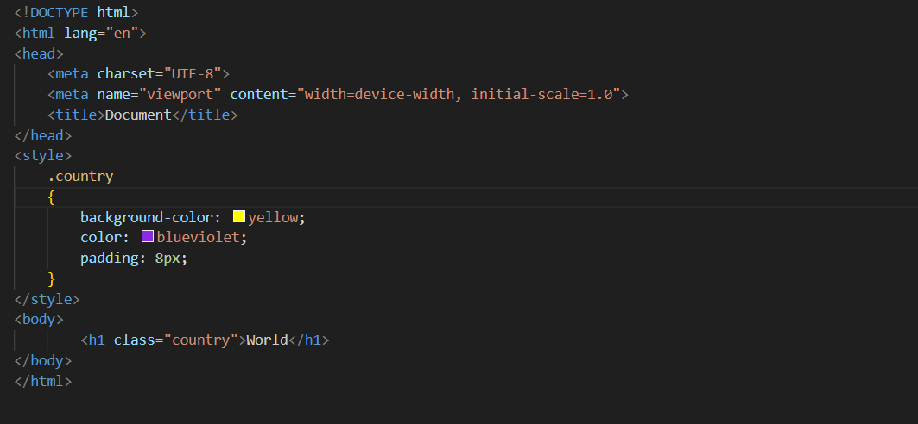

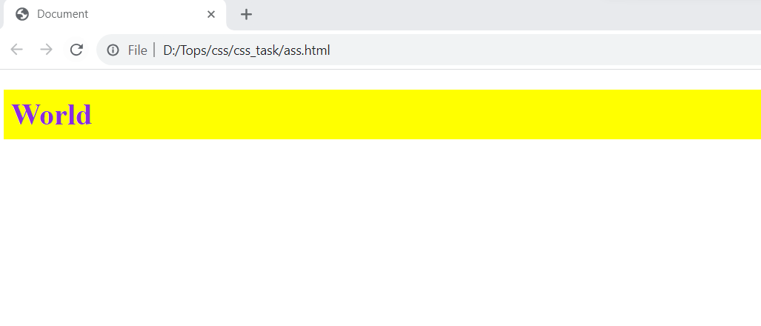

Q-7 What is the difference between the ‘id’ attribute and the ‘class’ attribute of HTML elements?

**Ans:** A class name can be used by multiple HTML elements, while an ID name must only be used by one HTML element within the page.

**Example:**

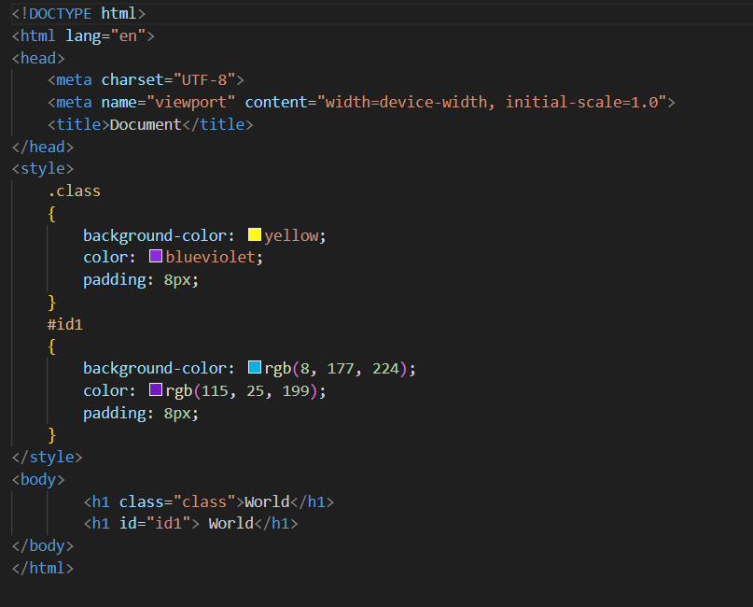

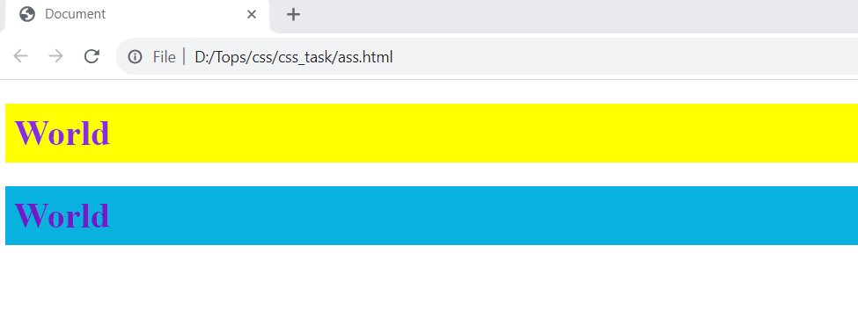

Q-8: What are the various formatting tags in HTML?

**ANS:**  In HTML formatting tags are divided into two categories.

Physical tag: These tags are used to provide the visual appearance to the text.

Logical tag: These tags are used to add some logical or semantic value to the text.

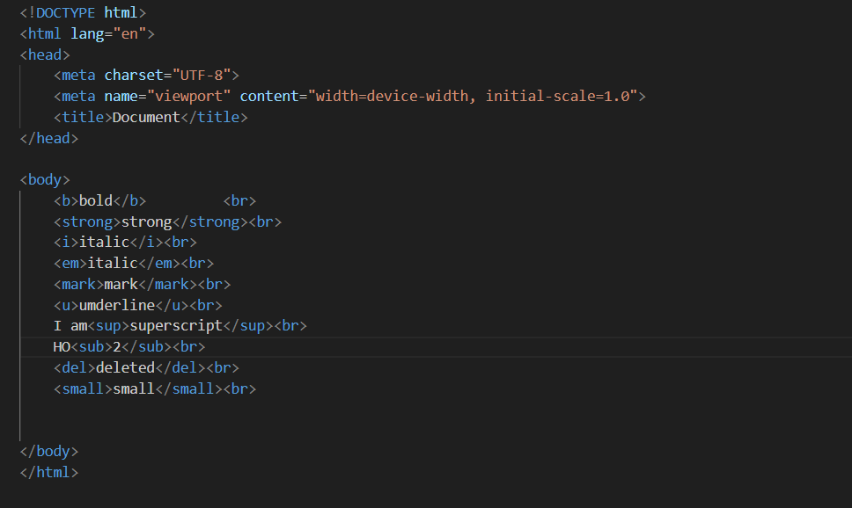

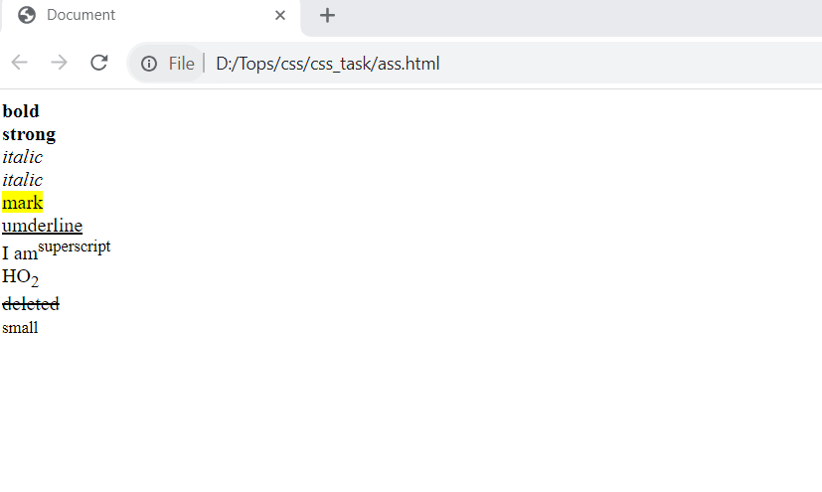

Q-9 How is Cell Padding different from Cell Spacing?

**ANS:** Cellpadding specifies the space between the border of a table cell and its contents (i.e) it defines the whitespace between the cell edge and the content of the cell.

Cellspacing specifies the space between cells (i.e) it defines the whitespace between the edges of the adjacent cells.

**Example:**

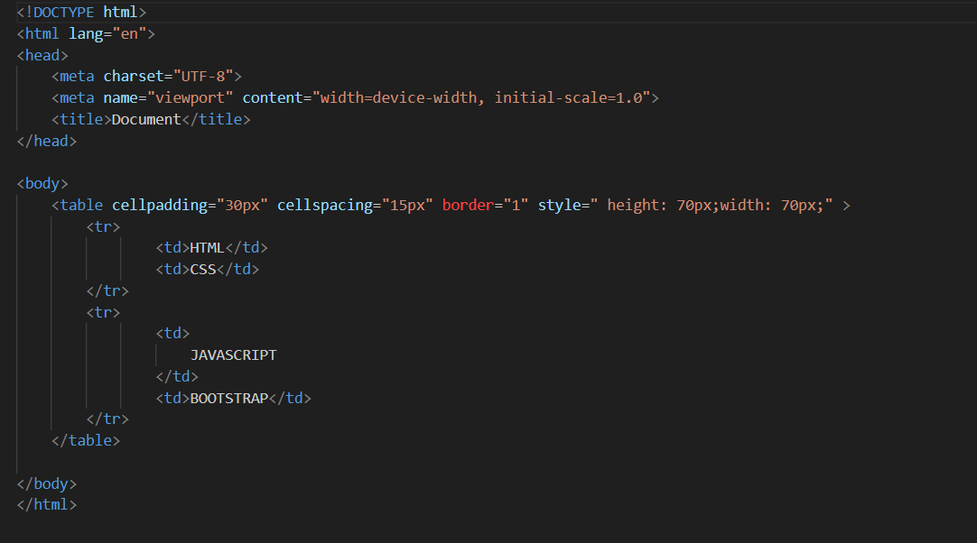

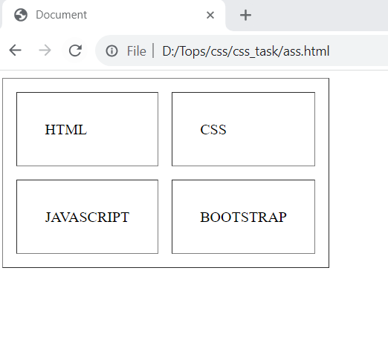

Q-10 How can we club two or more rows or columns into a single row or column in an HTML table?

**ANS:** we are club two or more rows or columns into a single row or column in an html by rowspan and colspan   
 **Example:**

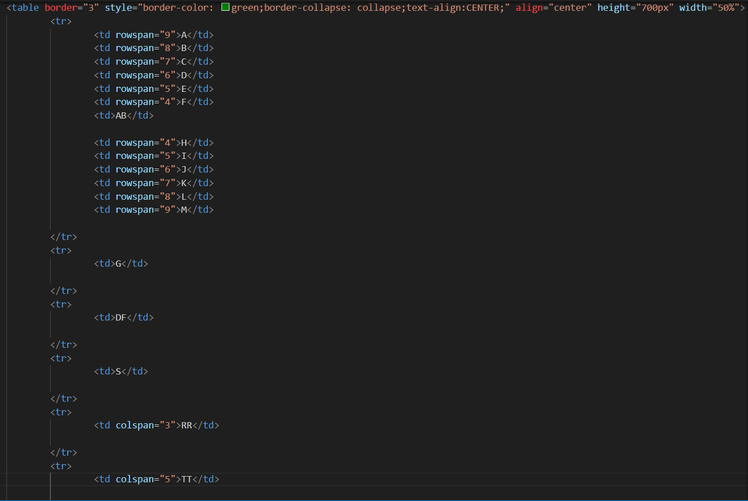

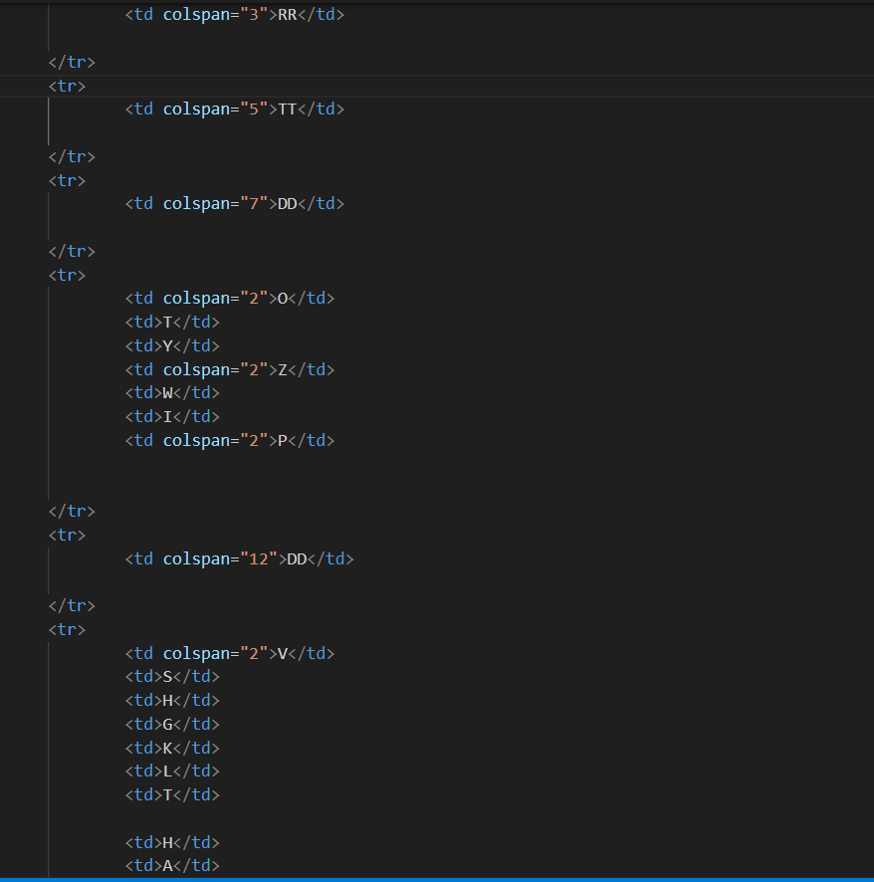

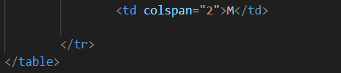

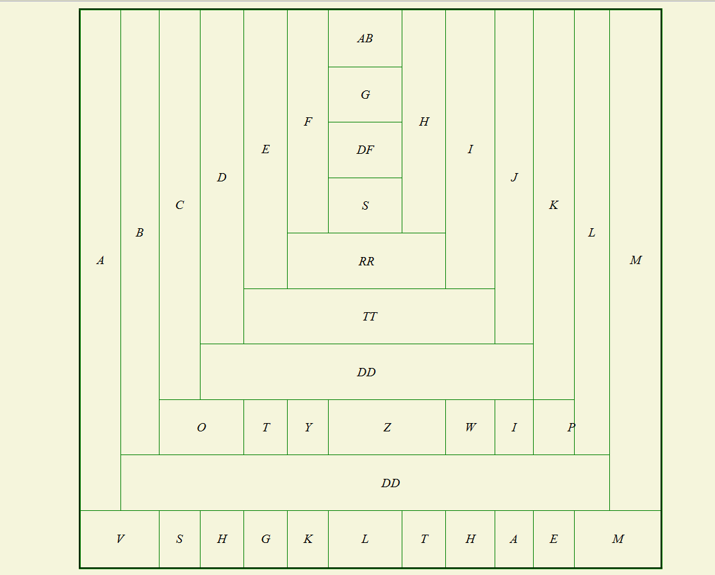

Q-11 What is the difference between a block-level element and an inline element?

**ANS:**

|  |  |
| --- | --- |
| **Block-level element** | **Inline element** |
| A block-level element always starts on a new line, and the browsers automatically add some space (a margin) before and after the element. | An inline element does not start on a new line. |
| Two commonly used block elements are: <p>and <div>.  The <p> element defines a paragraph in an HTML document.  The <div> element defines a division or a section in an HTML document. | Inline elements are:  <a>, <abr>, <b>, <i>, <image>,  <span>, <select> etc. |

**Example:**

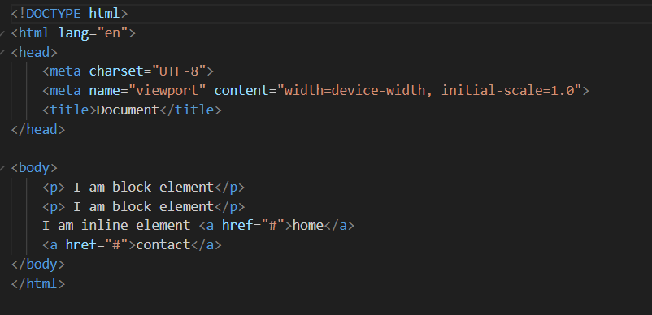

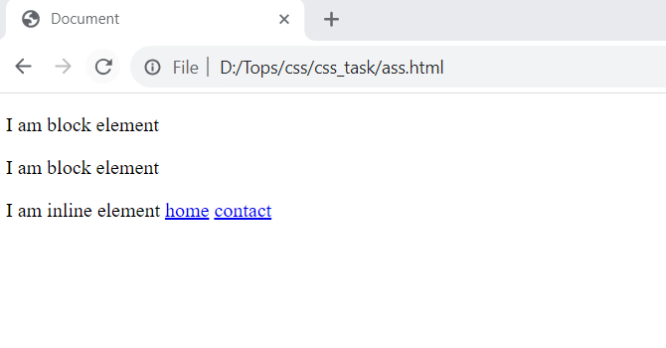

Q-12 How to create a Hyperlink in HTML?

**ANS:** Hyperlinks are one of the most exciting innovations the Web has to offer.Hyperlinks allow us to link documents to other documents or resources, link to specific parts of documents, or make apps available at a web address.

Hyperlink in HTML are created with help of anchor tag <a>.

**Example:**

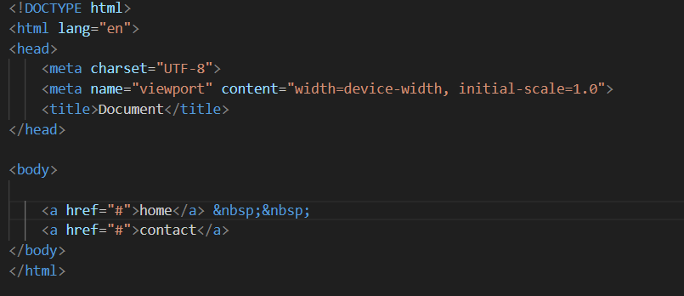

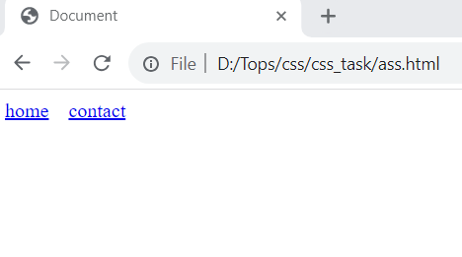

Q-13 What is the use of an iframe tag?

**ANS:** The iframe tag is used to embed an image in an HTML page.

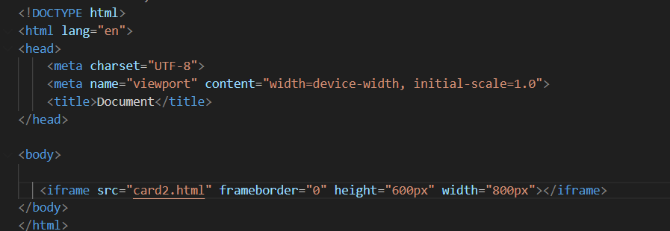

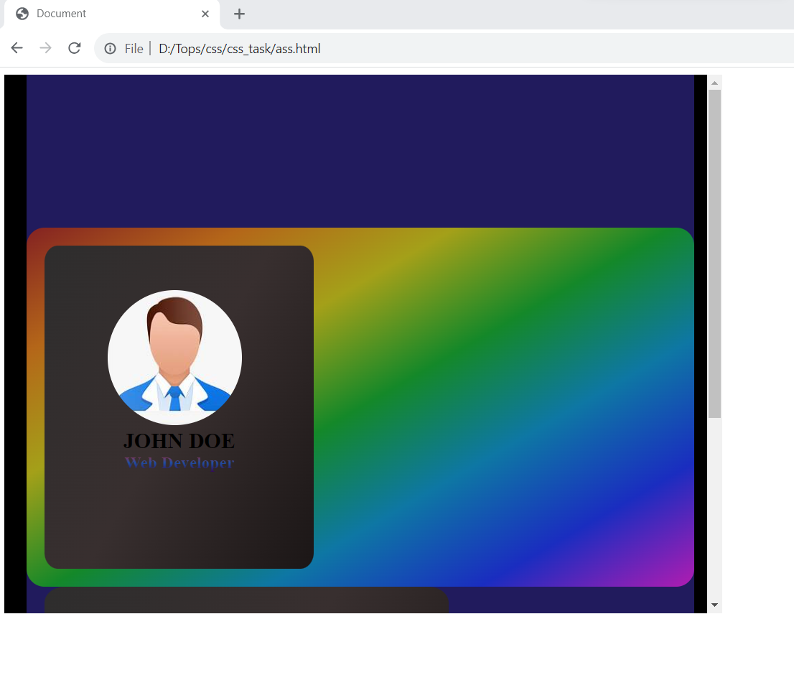

Q-14 What is the use of a span tag? Explain with example?

**ANS:** The span tag is an inline container used to mark up a part of a text, or a part of a document.

The span tag is easily styled by CSS or manipulated with JavaScript using the class or id attribute.

The span tag is much like the <div> element, but <div> is a block-level element and span is an inline element.

**Example:**

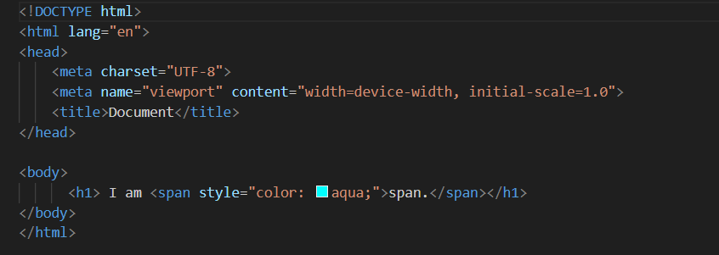

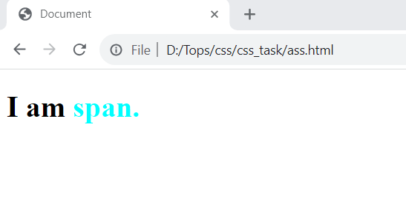

Q-15 How to insert a picture into a background image of a web page?

**ANS:** To add a background image on an HTML element, use the HTML style attribute and the CSS background-image property:

Example:

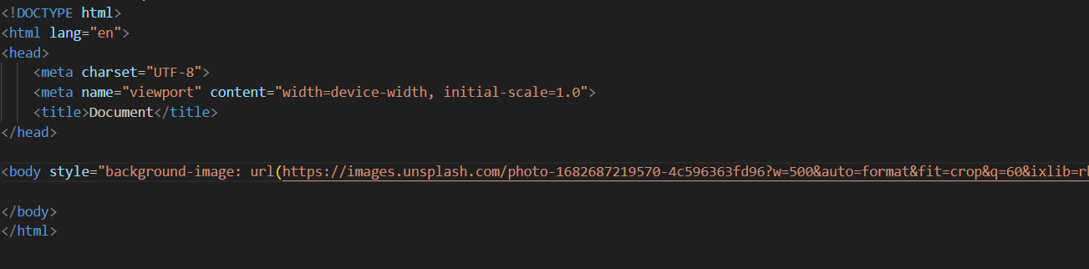

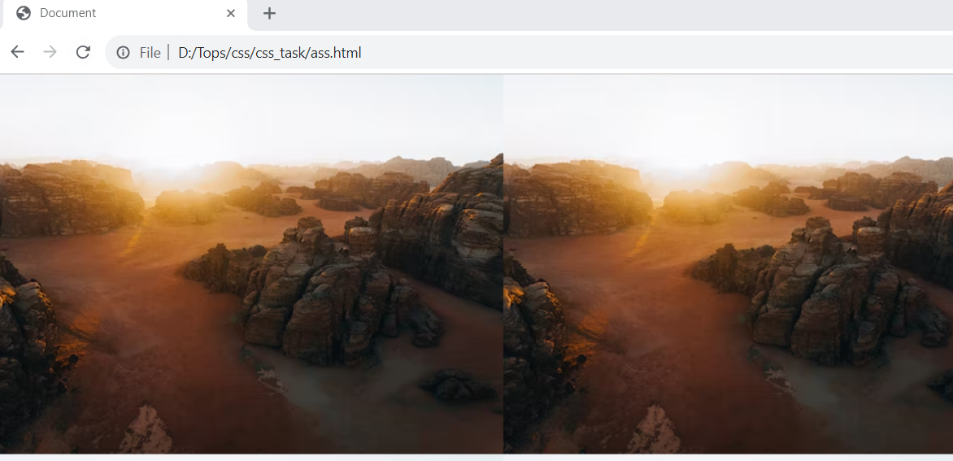

Q-16 How are active links different from normal links?

**ANS:** Normal link:

Example:

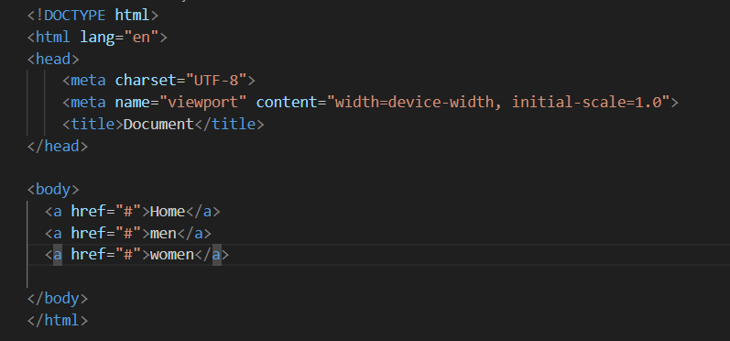

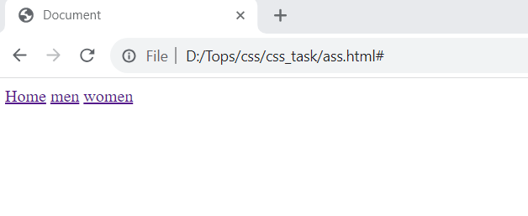

Clicking across the link in normal link does not change the color of the link.

Active link:

Example:

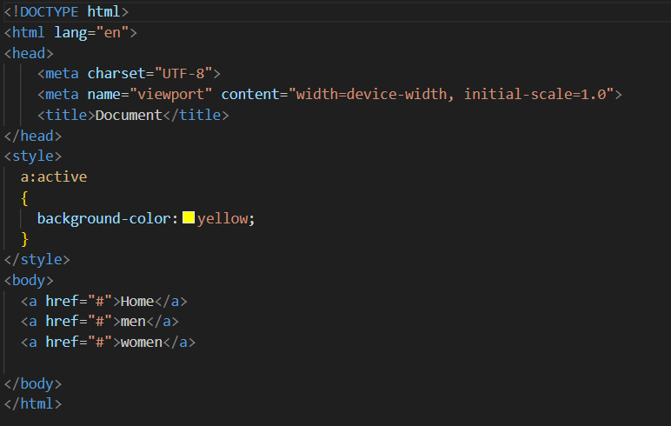

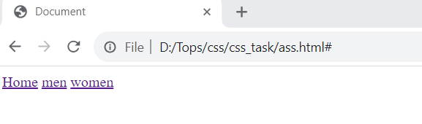

In example,If you left or right-click any one of the links Visited or Unvisited, it will turn into Red and Underline. Active Links shows that the browser is in the process to load a new resource.  You can do your own custom styling using CSS: active selector. In the above output, notice the active link on right-click of the link.

Q-17 What are the different tags to separate sections of text?

ANS: Three tags are used to separate the texts.  
  
 <br> tag - Usually <br> tag is used to separate the line of text. It breaks the current line and conveys the flow to the next line  
  
<p> tag - The <p> tag contains the text in the form of a new paragraph.  
  
<blockquote> tag - It is used to define a large quoted section. If you have a large quotation, then put the entire text within <blockquote>.............</blockquote> tag.

**Example**

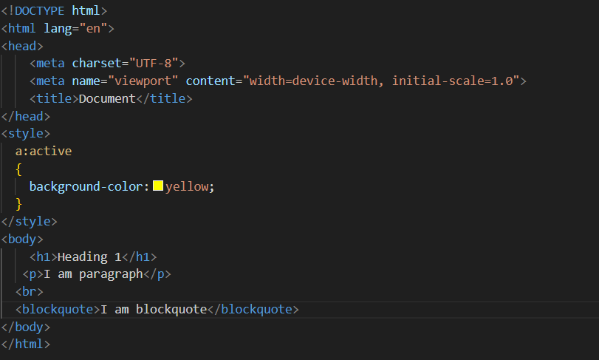

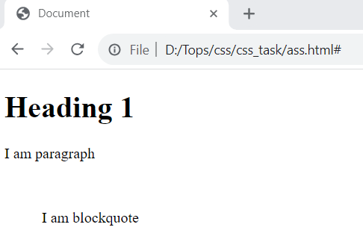

Q-18 What is SVG?

ANS: SVG stands for Scalable Vector Graphics.SVG is used to define graphics for the Web.

The HTML <svg> element is a container for SVG graphics.

SVG has several methods for drawing paths, boxes, circles, text, and graphic images.

**Advantages of SVG:**Advantages of using SVG over other image formats ( like JPEG and GIF) are:

* SVG images can be created and edited with any text editor.
* SVG images can be searched, indexed, scripted, and compressed.
* SVG images are scalable.
* SVG images can be printed with high quality at any resolution.

Example:

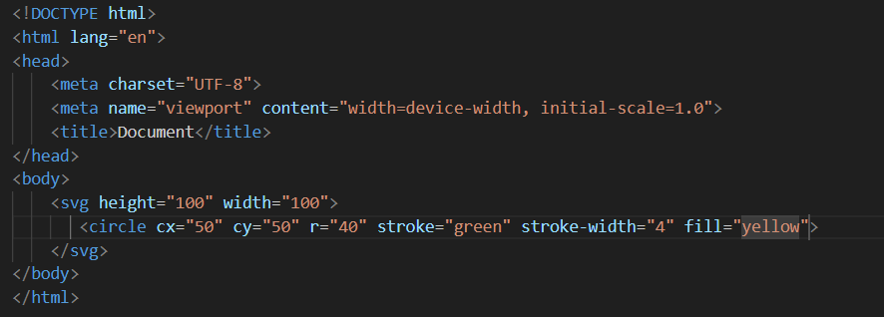

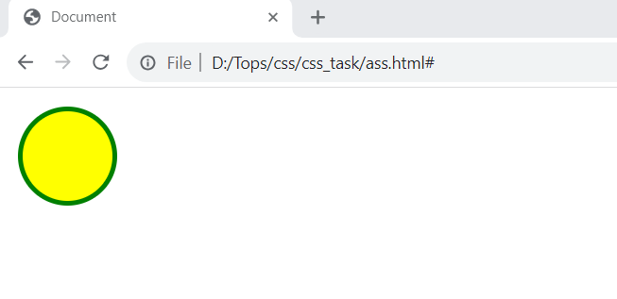

Q-19 What is difference between HTML and XHTML?

**ANS:**

|  |  |  |
| --- | --- | --- |
| **S.NO** | **HTML** | **XHTML** |
| 1. | HTML stands for Hypertext Markup Language. | XHTML stands for Extensible Hypertext Markup Language. |
| 2. | It was developed by Tim Berners-Lee. | |  | | --- | | It was developed by W3C i.e World Wide Web Consortium. | |  | |
| 3. | It was developed in 1991. | It was released in 2000. |
| 4. | The format is a document file format. | The format is a markup language. |
| 5. | All tags and attributes are not necessarily to be in lower or upper case. | In this, every tag and attribute should be in lower case. |
| 6. | Filename extension used are .html, .htm. | Filename extension are .xhtml, .xht, .xml. |
| 7. | It is not necessary to close the tags in the order they are opened. | It is necessary to close the tags in the order they are opened. |
| 8. | Doctype is not necessary to write at the top. | Doctype is very necessary to write at the top of the file. |
| 9. | It is extended from SGML. | it is extended from XML and HTML. |

Q-20 What are logical and physical tags in HTML?

**ANS:** Physical and Logical tags are used in HTML for better visibility and understanding of the text by the user on the web page. However, both tags differ from each other as suggested by their names.

**Logical Tags:**  
Logical Tags are used in HTML to display the text according to the logical styles.

**Example:**

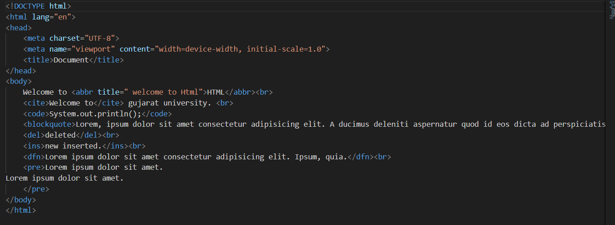

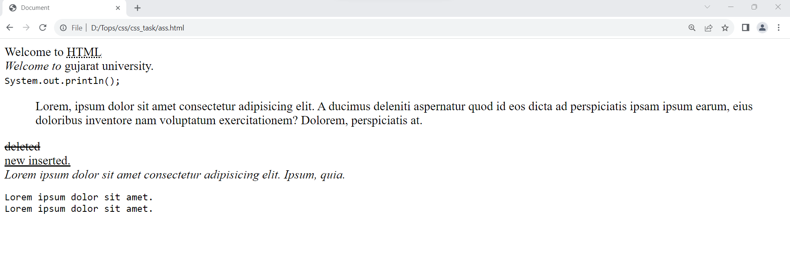

**Physical Tags**

Physical Tags are used in HTML to provide actual physical formatting to the text.

Example:

